INTUNE
Documentation Link
Scope Tags: Scope tags determine which objects admins can see.
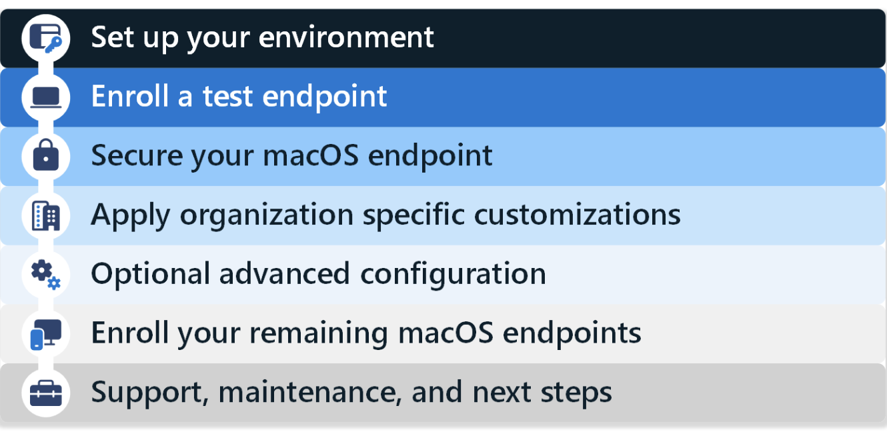
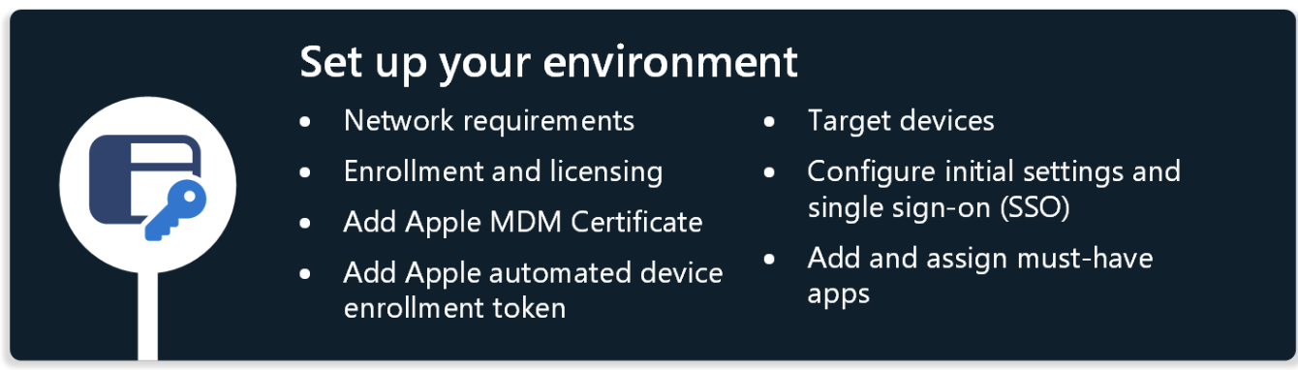

Step 1 - Network requirements: Set up your network

Here, we have to provide access to all the Network endpoints for MS Intune. Then, you can use your organization network to test your configuration.

Step 2 - Enrollment and licensing: Create a new group, configure enrollment restrictions, and assign licenses

To get the endpoints ready for enrollment, you need to make sure the correct endpoints are targeted and that the endpoints are licensed correctly.

Specifically:
- Create a new group: This is the group for testing; it’s created in Entra Portal and we add the users or devices to this group. We can name it the pilot group. For testing created configuration profiles, Compliance policies, we can apply these groups according to User or Device compatible profiles.

- Enrollment Restrictions: Enrollment restrictions allow you to control the types of devices that can enroll into Intune management. For this guide to be successful, in an enrollment restriction, make sure macOS (MDM) enrollment is allowed, which is the default configuration. Assign this enrollment restriction to the new group you created.
set Enrollment restrictions Guide

- Licenses:

Microsoft 365 Enterprise (Business Premium or E3/E5 licenses)
Microsoft Intune standalone licenses
Enterprise Mobility + Security (EMS) suites (EMS E3/E5)
Microsoft 365 Business Premium (for smaller organisations)

Types of Licenses and Plans
- Microsoft Intune or Microsoft 365 Licenses (which include Intune):
  - Microsoft Intune standalone licenses (for organizations that only need Intune).
  - Microsoft 365 Business Premium (for small businesses with basic device management needs).
  - Microsoft 365 Enterprise E3/E5 (includes Intune and other enterprise mobility and security features).
  - Enterprise Mobility + Security (EMS) E3/E5 (includes Intune as part of the EMS suite).
To use Automated Device Enrollment with Apple Business Manager, you’ll need either of the above licenses that include Intune.

Step 3 - Add the Apple MDM Certificate: Add the push certificate with a Managed Apple ID

Step 4 - Add the Apple automated device enrollment token: Link Apple token for Automated Device Enrollment

Step 5 - Target devices: Target specific groups using user groups, Intune filters or dynamic groups
macOS devices with user affinity can be targeted for profiles and apps using user or device groups. There are two common options for how organizations dynamically target devices:
Option 1 - All devices groups with an assignment filter on enrollmentProfileName
With assignment filter we can apply critical apps and polices to the endpoints
Option 2 – Microsoft Entra dynamic group based on enrollmentProfileName

Step 6 - Configure initial settings and single sign-on (SSO): Reduce app sign-in prompts with SSO

In Intune, you can configure settings that reduce the number of sign-in prompts end users receive when using apps, including Microsoft 365 apps. There are two parts to this configuration:

Devices > Manage devices > Configuration > Create > New policy > Settings catalog > Authentication > Extensible Single Sign On (SSO):

SSO profile creation link

Devices > Manage devices > Configuration > Create > New policy > Settings catalog > Microsoft Office > Microsoft Office: Add and configure the following settings:
- Office Activation Email Address: Enter {{userprincipalname}}.
- Enable automatic sign-in: Select True.

Step 7 - Add and assign must-have apps

How to add company portal app default app-> Ans:Link

To install company portal pre and post-install scripts

Steps to Deploy Company Portal .pkg with Pre/Post Install Scripts

1. Prepare the Company Portal .pkg
First, ensure that you have the Company Portal .pkg file that you want to deploy to macOS devices. You can either get this from the App Store or through other distribution methods.

2. Create Pre/Post Install Scripts
You can write shell scripts to execute custom tasks before or after the installation of the Company Portal app.

Example Pre-Install Script
A pre-install script can be used to run commands before the installation of the Company Portal app. This is useful for tasks such as clearing old configurations, stopping certain services, or setting system configurations.

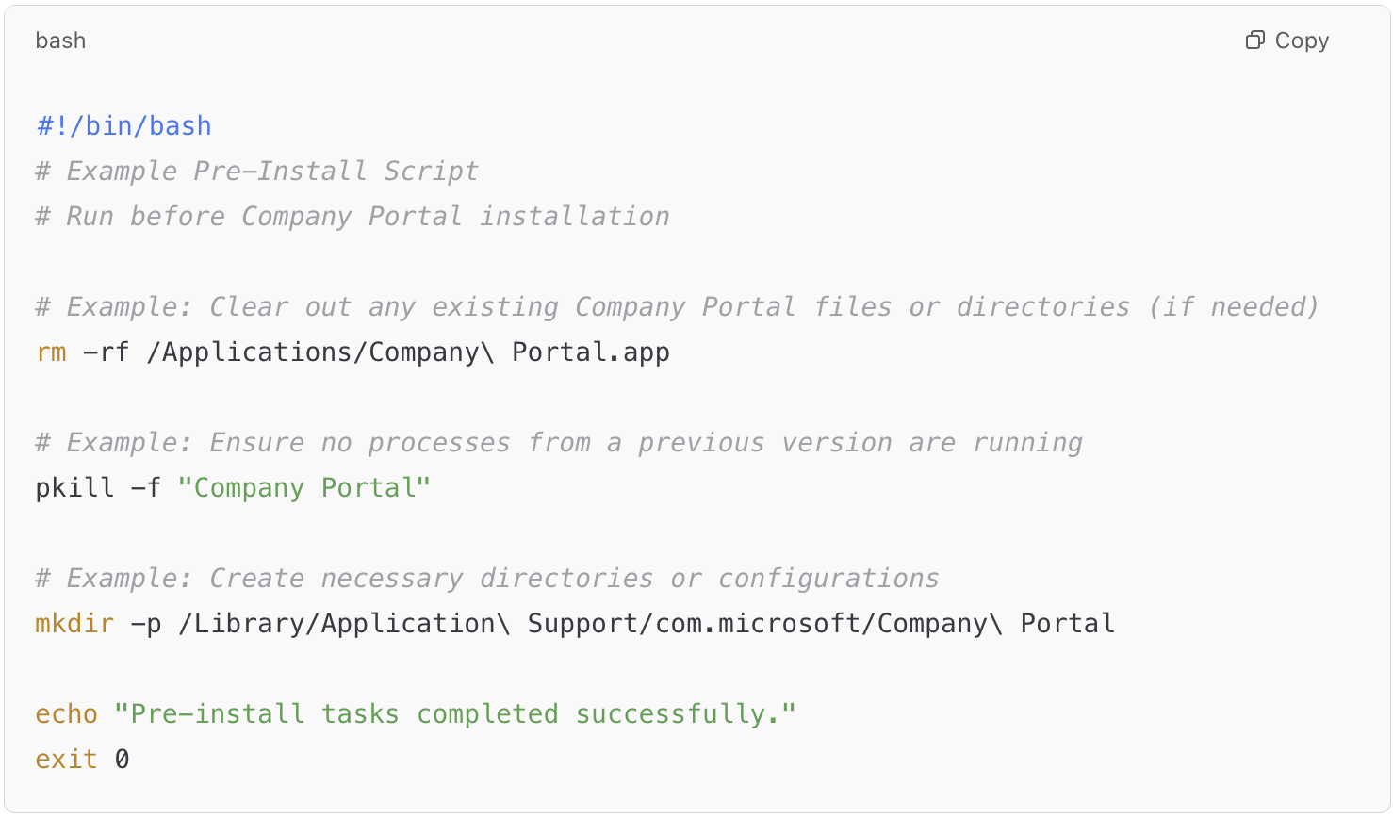

Example Post-Install Script
A post-install script runs after the installation completes. This can be used to configure the system, create directories, set file permissions, or run tasks that need to occur after the app has been installed.

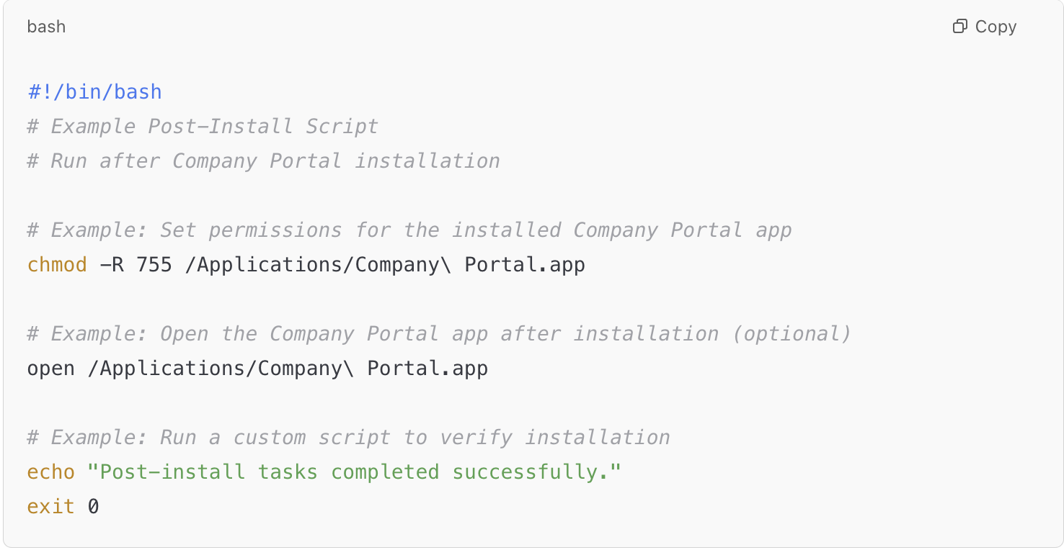

3. Package the .pkg with Pre/Post Install Scripts
You need to package the Company Portal app with your pre-install and post-install scripts into a single .pkg file.
There are various ways to package macOS apps and scripts into a single .pkg file. A common approach is to use tools like pkgbuild or productbuild to create the package, incorporating your pre/post install scripts.
Here’s how you can do it using pkgbuild:

Create a .pkg Using pkgbuild
- First, place the Company Portal app and your scripts in an appropriate directory structure.
Example structure:

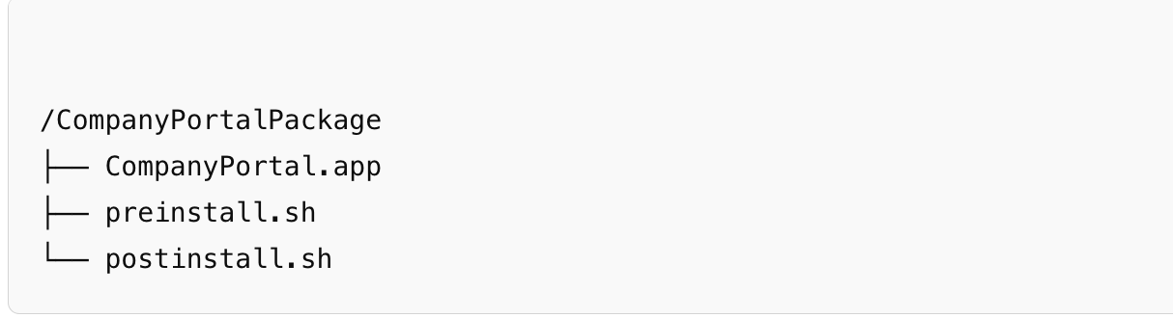

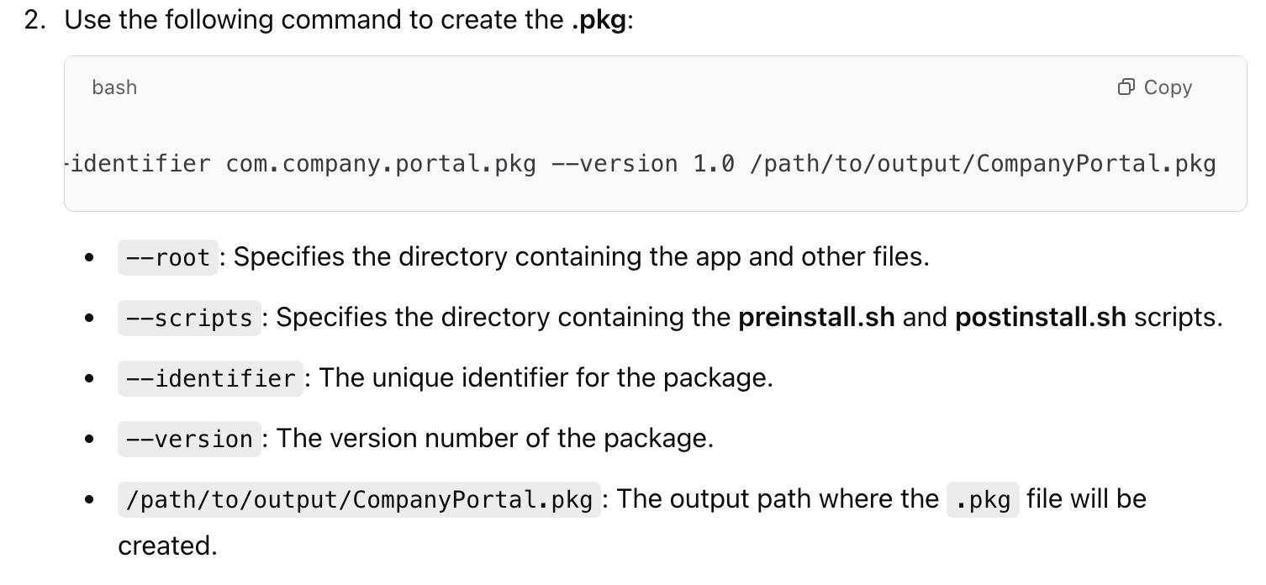

3.The resulting CompanyPortal.pkg file will now include the pre-install and post-install scripts as part of the installation process.

4. Deploy the .pkg with Intune
Once you have your .pkg file with the pre/post install scripts, you can deploy it through Microsoft Intune:
- Upload the .pkg:
  - In Microsoft Intune Admin Center, go to Apps > macOS > Add.
  - Choose Line-of-business app and upload your CompanyPortal.pkg file.
- Configure App Deployment:
  - Configure the app deployment settings, such as the assignment to device or user groups.
  - Ensure the app is set to Required so that it is installed automatically on the assigned devices.
- Deploy to Devices:
  - After configuring, deploy the app to the intended macOS devices.

5. Monitor the Installation
You can monitor the deployment process in Intune to ensure that the Company Portal app installs correctly and that your pre/post-install scripts run as expected.

Summary of Pre/Post Install Scripts:
- Pre-Install Script: Runs before the installation of the app. Use this to clear previous installations, stop services, or set configurations.
- Post-Install Script: Runs after the installation of the app. Use this for additional configuration tasks, permissions, app launching, or other post-install actions.
- Package the Company Portal app with these scripts using pkgbuild.
- Deploy the custom .pkg file using Intune to your macOS devices.
By using pre-install and post-install scripts, you can control additional steps to prepare the device or finalize the setup after the Company Portal app is installed.

Phase 2 - Enroll a test endpoint



The next phase enrolls a test macOS device into Intune. This phase gets you familiar with the initial steps so you're ready when it's time to enroll all your macOS devices in Intune.

When the user signs in, the enrollment policy applies. When it completes, your macOS endpoint is enrolled in Intune.

Phase 3 - Secure your macOS endpoints

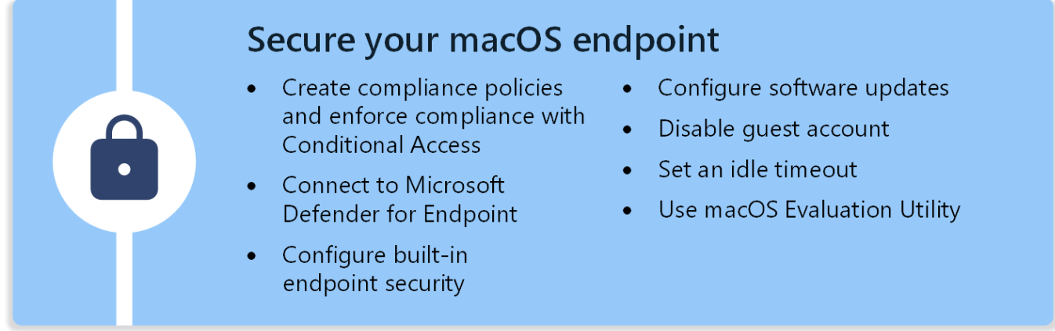
This section focuses on the different endpoint security features in Microsoft Intune, including:
- Compliance and Conditional Access policies
- Microsoft Defender for Endpoint
- FileVault, Firewall, and Gatekeeper endpoint security
- Software Updates
- Guest account
- Idle login
- Mac Evaluation Utility

1.Compliance and Conditional Access policies
Create compliance policies and enforce compliance with Conditional Access

Compliance policies verify the device settings you configure and can remediate some settings that aren't compliant. For example, you can create compliance policies that check password complexity, jailbroken status, threat levels, enrollment status, and more.
Intune compliance policies are divided into two areas:
- Compliance policy settings
- Device compliance policies
Compliance policy setting: Compliance policy settings are tenant-wide settings that determine how Intune’s compliance service interacts with your devices. These settings are distinct from the settings you configure in a device compliance policy.
To manage the compliance policy settings, sign in to Microsoft Intune admin center and go to Endpoint security > Device compliance > Compliance policy settings.
Compliance policy settings include the following settings:
- Mark devices with no compliance policy assigned as
This setting determines how Intune treats devices that aren't assigned a device compliance policy. This setting has two values:
  - Compliant (default): This security feature is off. Devices that aren’t sent a device compliance policy are considered compliant.
  - Not compliant: This security feature is on. Devices without a device compliance policy are considered noncompliant.
If you use Conditional Access with your device compliance policies, change this setting to Not compliant to ensure that only devices that are confirmed as compliant can access your resources.
If an end user isn't compliant because a policy isn't assigned to them, then the Company Portal app shows No compliance policies have been assigned.
Comploance status validity Period:
If a device fails to report its compliance status for a policy before the validity period expires, the device is treated as noncompliant.
By default, the period is set to 30 days. You can configure a period from 1 to 120 days
You can view details about a devices compliance to the validity period setting. Sign in to Microsoft Intune admin center and go to Devices > Monitor > Setting compliance. This setting has a name of Is active in the Setting column. For more information about this and related compliance status views, see Monitor device compliance.

Sure, I can help you set up a Conditional Access policy in Azure AD that requires users to be enrolled with the Company Portal to access resources. Here are the steps:
- Sign in to the Azure portal:
  - Go to Azure portal and sign in with your admin credentials.
- Navigate to Azure Active Directory:
  - In the left-hand navigation pane, select Azure Active Directory.
- Create a new Conditional Access policy:
  - Select Security > Conditional Access > New policy.
- Name your policy:
  - Give your policy a meaningful name, like "Require Company Portal Enrollment".
- Assign users and groups:
  - Under Assignments, select Users and groups.
  - Choose the users or groups that this policy will apply to.
- Cloud apps or actions:
  - Under Cloud apps or actions, select the applications you want to protect with this policy.
- Conditions:
  - You can set conditions like Sign-in risk, Device platforms, etc., but for this policy, you can skip this step.
- Access controls:
  - Under Grant, select Require device to be marked as compliant.
  - This ensures that only devices enrolled with the Company Portal and marked as compliant can access the resources.
- Enable policy:
  - Set Enable policy to On.
- Create:
  - Click Create to save your policy.
This policy will ensure that users must enroll their devices with the Company Portal and have them marked as compliant to access the specified resources. If you need more detailed guidance or have any questions, feel free to ask!

Device compliance policies:

Conditional Access can be used to enforce the compliance policies you create. When combined, end users can be required to enroll their devices and meet a minimum security standard before accessing organization resources. If a device is noncompliant, then you can block access to resources, like email, or require the user to enroll their device and fix the issue.

Note:
Policy refresh intervals:
When a device checks-in, it immediately checks for compliance, non-compliance and configuration for the current user/device context, receiving any pending actions, policies and apps assigned to it

There are 4 main types of check-ins:
- Scheduled check-ins- about every 8hrs all platform devices
- End user driven check-ins - Devices > Check Status or Settings > Sync
- Admin check-ins- device sync, remote lock or reset passcode. Other actions like remotely assist users
- Notification-based check-ins –

when devices first enroll, configuration check-ins run more frequently to perform configuration, compliance and non-compliance checks. The check-ins are estimated as follows:

Android, AOSP | Every 3 minutes for 15 minutes, then every 15 minutes for 2 hours, and then around every 8 hours

iOS/iPadOS | Every 15 minutes for 1 hour, and then around every 8 hours

macOS | Every 15 minutes for 1 hour, and then around every 8 hours

Windows 10/11 PCs enrolled as devices | Every 3 minutes for 15 minutes, then every 15 minutes for 2 hours, and then around every 8 hours

Note:

MS 365 Deployment Guide for MAC

Use FileVault disk encryption for macOS with Intune
Use one of the following policy types to configure FileVault on your managed devices:
- Endpoint security policy for macOS FileVault. The FileVault profile in Endpoint security is a focused group of settings that is dedicated to configuring FileVault.
View the FileVault settings that are available in profiles for disk encryption policy.
- Device configuration profile for endpoint protection for macOS FileVault. FileVault settings are one of the available settings categories for macOS endpoint protection. For more information about using a device configuration profile, see Create a device profile in Intune.
View the FileVault settings that are available in endpoint protection profiles for device configuration policy.
- Settings catalog profile for macOS FileVault. FileVault can be configured through the Intune settings catalog, which includes some settings that aren't available in the endpoint security and endpoint protection templates.

We can use this one

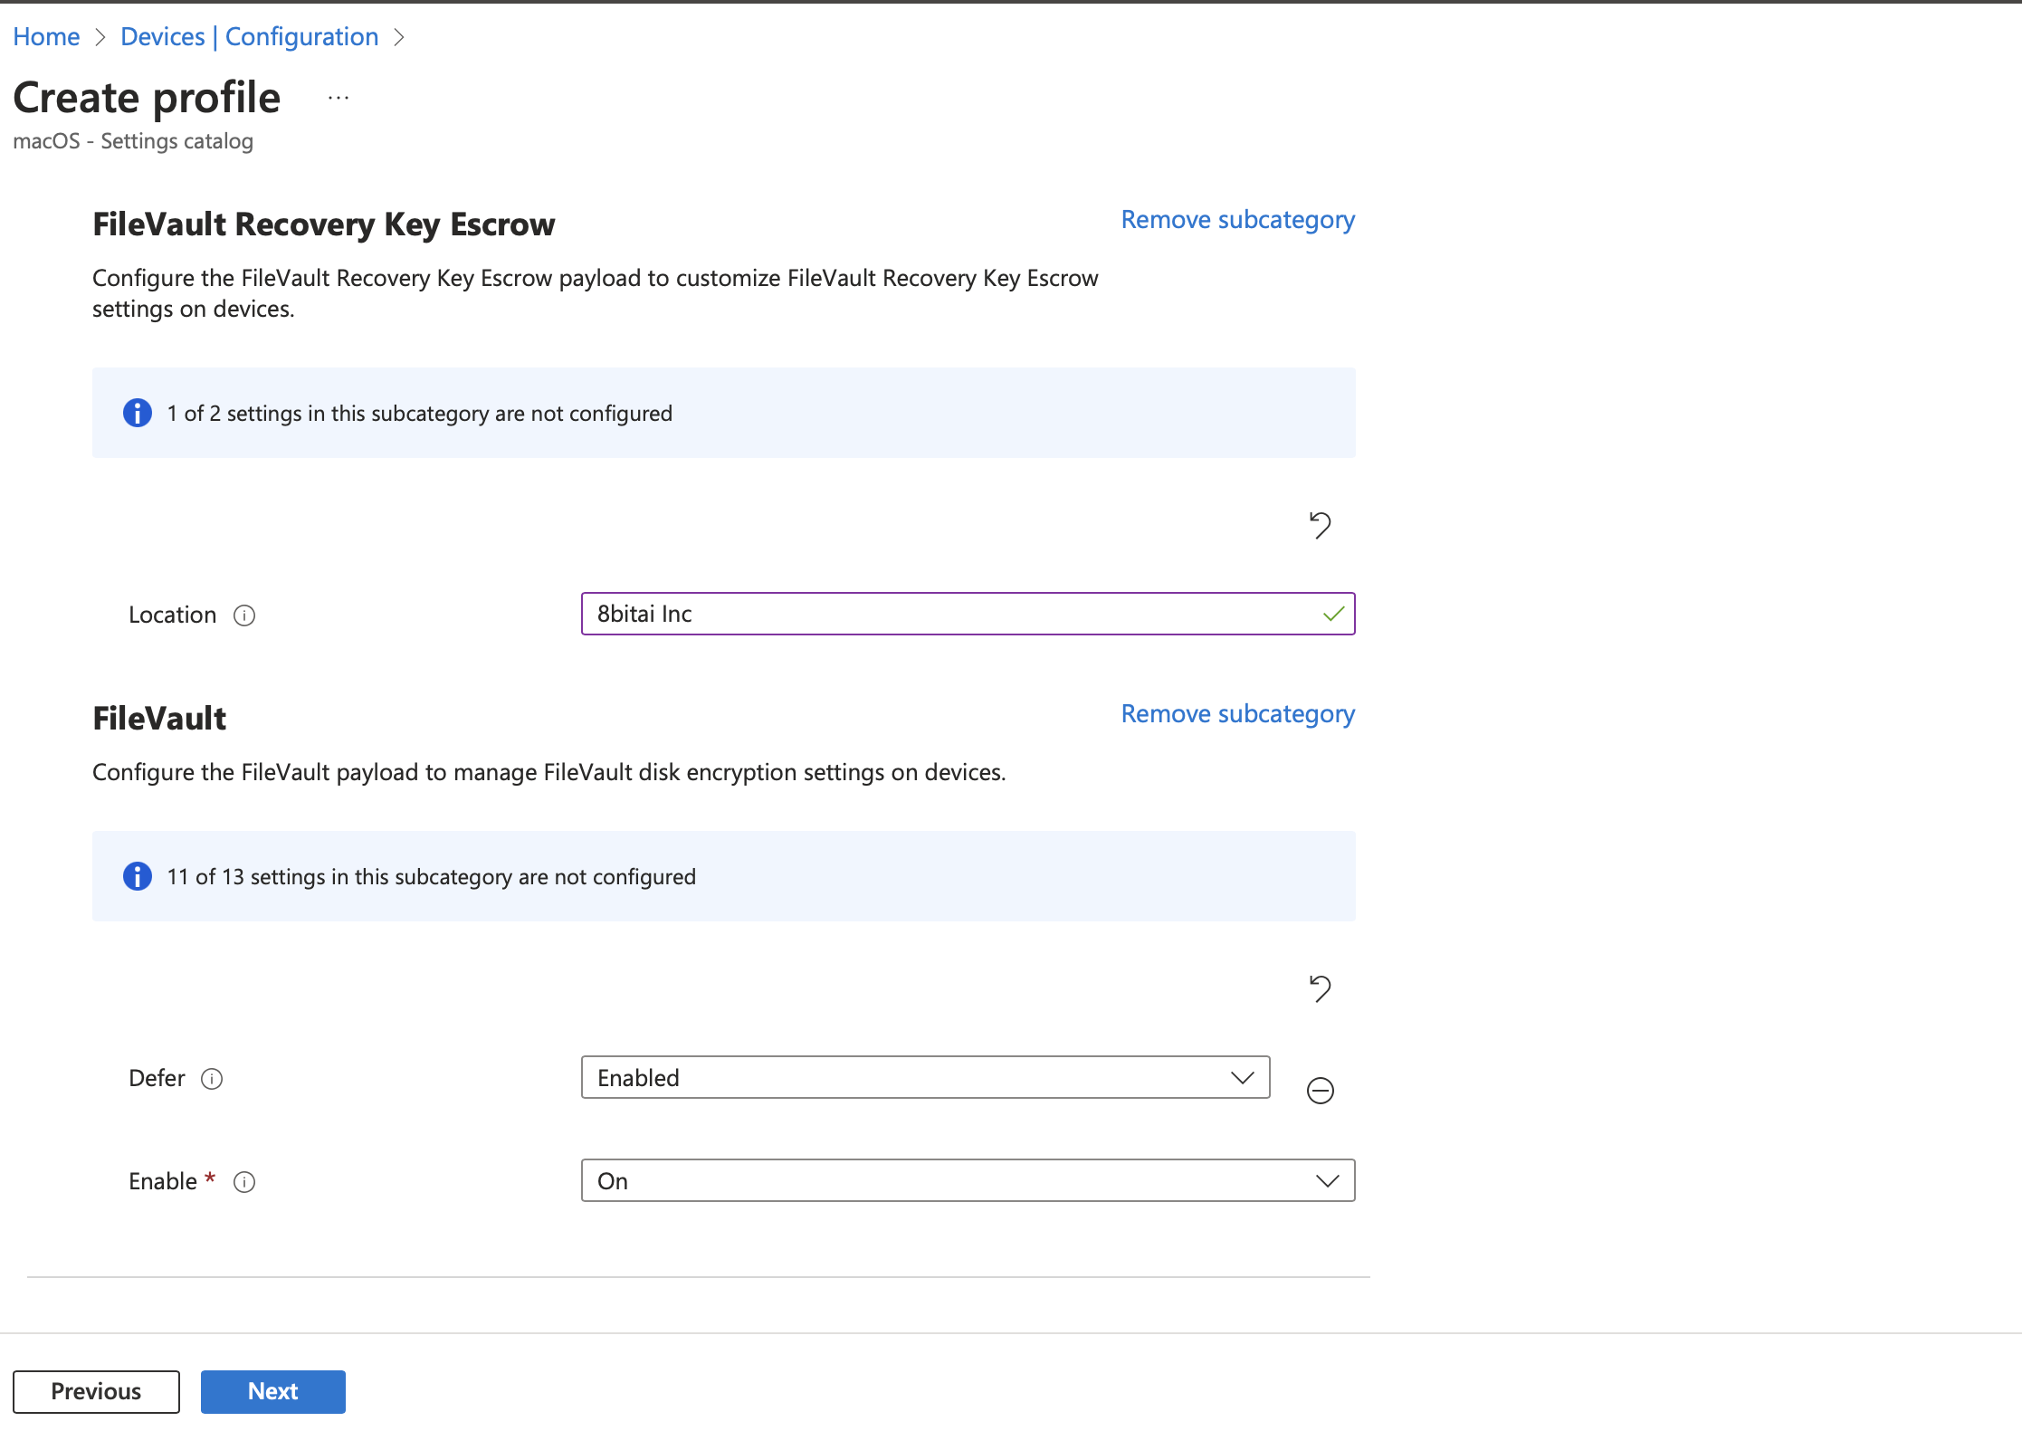
Or we can use this process: link for FileVault encryption configuration profile.

✅ Configure Gatekeeper
Gatekeeper makes sure that only trusted software runs on the device. The Gatekeeper settings are built into the Intune settings catalog and are available as compliance policies.
So, you can configure Gatekeeper, check for compliance, and deploy the policies to your devices.
To create these policies, in the Intune admin center, go to:
- Devices > Manage devices > Configuration > Create > New policy > Settings catalog > System policy > System Policy Control:
  - Allow Identified Developer: Select True.
  - Enable Assessment: Select True.
- Devices > Manage devices > Configuration > Create > New policy > Settings catalog > System policy > System Policy Managed:
  - Disable Override: Select True.
- Devices > Manage devices > Compliance > Create policy > System Security > Gatekeeper

For more information about Gatekeeper, go to:
- Use the settings catalog to configure settings in Microsoft Intune
- Gatekeeper and runtime protection in macOS (opens Apple's website)

How do I setup a firewall configuration policy?
Link: Firewall

Tutorials for integrating applications with Microsoft Entra ID

1. Device Enrollment Policy (Automatic Enrollment)
For macOS devices to be onboarded into Intune, you need to configure Automated Device Enrollment (ADE) or Apple School Manager/Apple Business Manager (ABM) integration. This is typically part of the Apple Configurator 2 or ABM setup.
Steps:
- Apple Automated Device Enrollment (ADE) allows automatic enrollment of macOS devices.
- Apple Configurator 2 can be used to enroll macOS devices if not using ABM.
- This process requires a Company Portal app installation to complete the user/device profile.

2.Enrollment Profile:

Create an Enrollment Profile
- Go to:
Intune Admin Center > Devices > macOS > Enrollment > Enrollment program tokens.
- Select your DEP token and click Profiles.
- Click Create Profile and configure:
  - Profile Name: e.g., macOS Enrollment Profile
  - Description: (optional)
  - User Affinity:
    - With User Affinity – For company devices linked to a user. (Requires Azure AD login)
    - Without User Affinity – For shared or kiosk devices.
  - Device Name: Set a naming convention (optional).
  - MDM Terms of Use: Define if required.
  - Setup Assistant Customization:
    - Skip or Show Setup Screens (e.g., location, Apple ID, Touch ID, etc.).
- Click Next and Create.

3.Enrollment Restrictions to limit which macOS devices can be enrolled.

Enrollment Restrictions to Limit macOS Devices in Intune
To restrict which macOS devices can be enrolled in Microsoft Intune, you need to configure Enrollment Restrictions in Intune.

Step 1: Access Enrollment Restrictions
- Go to the Intune Admin Center
  - https://endpoint.microsoft.com
- Navigate to Devices → Enrollment → Enrollment restrictions.

Step 2: Create or Modify a Restriction Policy
- Click Create restriction (or modify an existing one).
- Select Device Type Restriction or Enrollment Restriction.
- Configure the following settings:

Option 1: Block Personal (BYOD) macOS Enrollment
- Go to Device type restrictions → Create restriction.
- Under Platforms, set:
  - Personal macOS → Block.
  - Corporate macOS → Allow.
- This ensures only corporate-owned macOS devices (from ABM) can enroll.

Option 2: Restrict macOS Enrollment to Specific Models
- Under Platform configurations, add allowed macOS versions (e.g., macOS 12+ only).
- You can set a minimum or maximum OS version.

Option 3: Restrict Enrollment Based on Device Serial Numbers
- Go to Devices → Enrollment → Enrollment program tokens.
- Select your DEP token and under Devices, remove unapproved serial numbers.

Option 4: Restrict Enrollment to Specific Users or Groups
- Under Assignments, allow enrollment only for specific Azure AD groups (e.g., "IT Staff").

Step 3: Assign and Apply the Restriction
- Click Next and assign it to a group (e.g., "Corporate macOS Devices").
- Click Create (or Save if editing an existing rule).
- Test enrollment with a blocked device to confirm restrictions.

Step 4: Monitor Enrollment Attempts
- Go to Intune Admin Center → Devices → Monitor → Enrollment failures.
- Review any failed enrollments and adjust policies if necessary.

Creating Compliance Policies for macOS in Intune
To ensure that macOS devices meet security requirements (e.g., FileVault, password policies, etc.), you can create Compliance Policies in Microsoft Intune.

Step 1: Navigate to Compliance Policies
- Go to the Intune Admin Center → https://endpoint.microsoft.com
- Click Devices → macOS → Compliance policies.
- Click Create policy and select macOS.

Step 2: Define Compliance Rules
- Enter a Policy Name (e.g., macOS Security Compliance).
- Click Next and configure the following compliance settings:

1️⃣ Require FileVault (Disk Encryption)
- FileVault → Require
  - Ensures macOS disk encryption is enabled.
  - Users must enable FileVault for compliance.

2️⃣ Password Requirements
- Require password → Yes
- Minimum password length → Set (e.g., 8 or more characters)
- Password complexity → At least numeric + alphabetic
- Maximum inactivity time before lock → (e.g., 5 minutes)
- Password expiration → (Optional, e.g., 90 days)
- Prevent reuse of old passwords → (Optional, e.g., 5 previous passwords)

3️⃣ Require Firewall
- macOS Firewall → Require
  - Ensures the built-in macOS Firewall is enabled for network security.

4️⃣ Block Jailbroken or Compromised Devices
- Device Threat Level (if using Defender or SentinelOne)
  - Set Low (Blocks devices with high-security risks).

5️⃣ Minimum macOS Version
- Minimum OS version → Set a baseline OS version (e.g., macOS 12.0).
- Maximum OS version → (Optional, for preventing outdated OS versions).

Step 3: Assign Compliance Policy
- Click Next → Assignments.
- Assign the policy to All Devices or specific Azure AD Groups.

Step 4: Set Actions for Non-Compliance
- Under Actions for noncompliance, configure:
  - Mark device as noncompliant: Immediately.
  - Send email to user: Notify users if their device is non-compliant.
  - Remediate noncompliance: Provide instructions to fix issues.
  - Block access using Conditional Access (Optional but recommended).

Step 5: Save & Deploy the Policy
- Click Create.
- The policy will apply during the next device sync.

Step 6: Monitor Compliance Status
- Go to: Intune → Devices → Monitor → Device compliance.
- Review devices failing compliance and troubleshoot issues.

These settings are used to manage macOS update deferrals in Microsoft Intune under Software Update Policies. Here's what they mean and recommended values:

🔹 Deferrals in macOS Software Updates
Deferral settings control how long macOS updates are postponed before being available to users.
✅ Major Period in Days (Recommended: 30-90 days)
- Defines how long major macOS updates (e.g., macOS 13 → macOS 14) are deferred before they appear in Software Update on the device.
- Example: If set to 60 days, users won’t see macOS Sonoma (14.x) available for 60 days after release.
✅ Minor Period in Days (Recommended: 7-14 days)
- Delays minor updates (e.g., macOS 14.1 → macOS 14.2) before users see them.
- Example: Setting 14 days ensures a 2-week delay before the update appears.
✅ System Period in Days (Recommended: 7-30 days)
- Delays system/security updates (e.g., security patches, firmware updates).
- Example: Setting 7 days delays security updates for one week before being visible to end users.
✅ Allow Standard User OS Updates (Recommended: Disabled for controlled environments, Enabled for BYOD)*
- If enabled, standard users (non-admin) can manually check and install macOS updates.
- If disabled, only admins can install updates (useful for controlled enterprise environments).

🔹 Example Configuration for a Managed Enterprise Mac Environment
Setting | Recommended Value
Major Period in Days | 60
Minor Period in Days | 14
System Period in Days | 7
Allow Standard User OS Updates | Disabled
This configuration ensures:
✅ Major updates are delayed for 2 months to prevent unexpected issues.
✅ Minor updates are delayed for 2 weeks for stability testing.
✅ Security updates are only delayed by 7 days to ensure timely patching.
✅ Users cannot manually update macOS (ideal for IT-managed devices).

🎯 Summary
- Set Major Period = 60 days (Delays major OS upgrades)
- Set Minor Period = 14 days (Delays minor updates)
- Set System Period = 7 days (Delays security updates)
- Disable Standard User OS Updates for better IT control

Managed Apps vs. Managed Devices in Microsoft Intune
When configuring app protection policies or app configuration policies in Intune, you have two choices:

1️⃣ Managed Apps (App Protection Policies - MAM)
✅ Used for: Protecting corporate data inside specific apps without managing the entire device.
✅ Best for: BYOD (Bring Your Own Device) scenarios where users don't want full device management.

🔹 Key Features
- Only Microsoft apps (e.g., Outlook, OneDrive, Teams, Edge) and approved third-party apps are managed.
- Corporate data inside the app is isolated from personal data.
- Enforces policies like copy/paste restrictions, encryption, and data wipe on sign-out.
- No need for device enrollment in Intune.

🔹 Example Use Case
A user installs Outlook on their personal iPhone. You apply an Intune App Protection Policy (MAM) to ensure:
✅ Emails are encrypted.
✅ No copy-pasting of company emails outside Outlook.
✅ Outlook data gets wiped when the user leaves the company.
📌 How to Choose This in Intune?
When creating an App Protection Policy, select Managed Apps to apply policies to only work apps.

2️⃣ Managed Devices (MDM - Mobile Device Management)
✅ Used for: Managing the entire device and all installed apps, including system-wide configurations.
✅ Best for: Company-owned or fully managed devices where IT needs full control.

🔹 Key Features
- Enforces device-wide security policies (e.g., password rules, full disk encryption, remote wipe).
- Configures Wi-Fi, VPN, email settings, and compliance rules.
- Applies security policies to all apps (Microsoft + third-party).
- Requires device enrollment in Intune (via Company Portal app or Apple Automated Device Enrollment).

🔹 Example Use Case
A company gives an employee a corporate MacBook. IT uses Managed Devices (MDM) to:
✅ Enforce FileVault encryption.
✅ Deploy Wi-Fi and VPN settings.
✅ Install apps like Microsoft 365, Zoom, SentinelOne.
✅ Block personal app installations.
📌 How to Choose This in Intune?
When creating a Device Configuration Policy, select Managed Devices to apply policies to the whole device.

🎯 When to Use Which?
Feature | Managed Apps (MAM) | Managed Devices (MDM)
Device Ownership | Personal (BYOD) | Corporate-Owned
Requires Enrollment | ❌ No | ✅ Yes
Protects Corporate Data | ✅ Yes (inside apps only) | ✅ Yes (entire device)
Enforces Device Settings | ❌ No | ✅ Yes
Restricts Copy/Paste | ✅ Yes | ✅ Yes
Remote Wipe | ✅ Only app data | ✅ Full device wipe

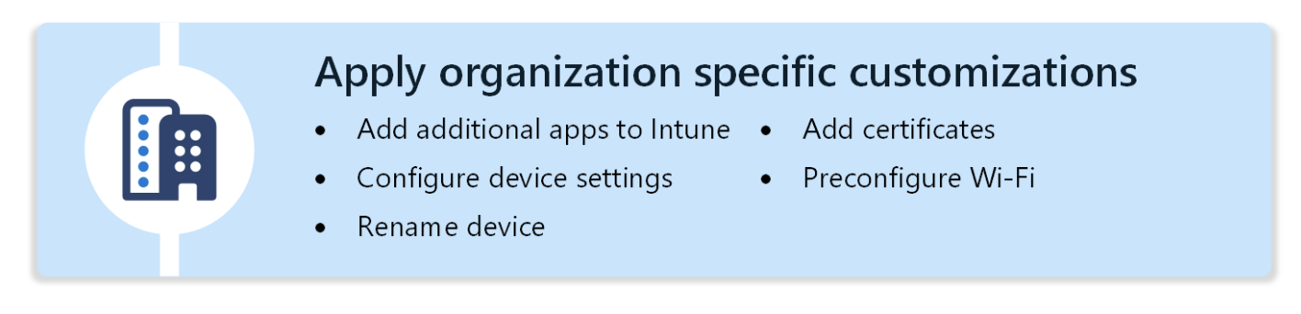

To restrict browser settings on macOS using Intune, you'll need to use custom configuration profiles with preference domain keys (.plist) specific to the browser (e.g., Safari, Chrome, Firefox). Here’s how you can do it step-by-step:

Step-by-Step: Restrict Browser Settings via Intune

1. Choose the Browser
Common macOS browsers:
- Safari (native)
- Google Chrome
- Mozilla Firefox
Each uses different preference domains.

2. Use Configuration Profiles (.plist XML)
You’ll need to create a custom configuration profile (XML format) for the browser you want to manage.
Safari is managed using the domain: com.apple.Safari
<?xml version="1.0" encoding="UTF-8"?>
<!DOCTYPE plist PUBLIC "-//Apple//DTD PLIST 1.0//EN"
"http://www.apple.com/DTDs/PropertyList-1.0.dtd">
<plist version="1.0">
<dict>
<key>com.apple.Safari</key>
<dict>
<key>AutoFillPasswords</key>
<false/>
<key>BlockPopUps</key>
<true/>
</dict>
</dict>
</plist>

Chrome is managed via: com.google.Chrome

<?xml version="1.0" encoding="UTF-8"?>
<!DOCTYPE plist PUBLIC "-//Apple Computer//DTD PLIST 1.0//EN"
"http://www.apple.com/DTDs/PropertyList-1.0.dtd">
<plist version="1.0">
<dict>
<key>com.google.Chrome</key>
<dict>
<key>IncognitoModeAvailability</key>
<integer>1</integer>
</dict>
</dict>
</plist>

1 = Disable Incognito mode
2 = Force Incognito
0 = Allow Incognito

Create a Custom Profile in Intune
• Go to Intune Admin Center
➡️ Devices > macOS > Configuration profiles > Create profile
• Platform: macOS
Profile type: Custom
• Upload your .plist as a Custom configuration profile
• Assign the profile to user/device groups.

Tools will help:
• ProfileCreator (Mac app) – GUI tool to build config profiles
• iMazing Profile Editor – Also good for editing .mobileconfig

